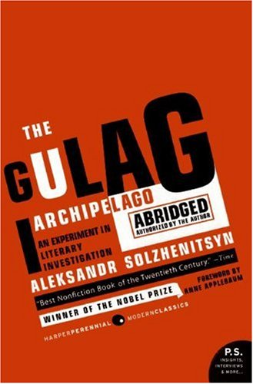
The Gulag Archipelago

Aleksandr Solzhenitsyn, The Gulag Archipelago, 1918-1956: An Experiment in Literary Investigation, Trans. Thomas P. Whitney & Harry Willets (New York: Harper Perennial Modern Classics, 2007)

Summary:

“In this book there are no fictitious persons, nor fictitious events,” says Aleksandr Solzhenitsyn, author of The Gulag Archipelago, a book written in secret between the years 1958 and 1968, not published until 1973—and only in the West, since his works were banned in Russia. Solzhenitsyn was first arrested in 1945 for criticizing Stalin in a private letter. He was sentenced to eight years in Russia’s gulags, where he abandoned Marxism and converted to Christianity. GULAG is a Russian acronym for “Main Camp Administration,” a Soviet agency that ran the forced labor camps where millions of Russians died. What Solzhenitsyn produced is “an experiment in literary investigation” in which he details the beginnings of the penal system, Lenin and Stalin’s roles, interrogations, camp conditions, revolts, and the social dynamics in camps.

He won the Nobel Prize in 1970 for his writing, among which was a fictional account of the gulags called One Day in the Life of Ivan Denisovich (1962). Soon after came The Gulag Archipelago, what TIME calls the “best nonfiction book of the twentieth century.” From the testimony of hundreds of prisoners, or zeks, Solzhenitsyn fiercely criticizes totalitarianism in the Soviet Union and assembles a narrative that ensured that human rights became an international issue. Following its publication, he was arrested in 1974 for treason and subsequently deported. He raised a family in Vermont, where he continued to write. In 1994 he returned to Russia, where he died in 2008.

Themes, Motifs, & Symbols:

- Archipelago. Solzhenitsyn first used the term archipelago in his Nobel Prize speech that he smuggled out of Russia inside a portable radio. He uses the motif of a “chain of islands” spread out across Russia to describe the gulags.
- Duality. If people were completely evil, we could separate and destroy them, however, “the line dividing good and evil cuts through the heart of every human being.” Martin Luther’s related saying is simul iustus et peccator.
- Ideology. “[Ideology] is what gives evildoing its long-sought justification and gives the evildoer the necessary steadfastness and determination.”

Discussion Questions:

- The visual companion to Solzhenitsyn’s textual epic is the collection of paintings by Nikolai Getman. Compare and contrast the works of these two artists. You can also see my master’s thesis for more information on gulags.
- In his Nobel Prize speech, Solzhenitsyn said, “Falsehood can hold out against much in this world, but not against art. And no sooner will falsehood be dispersed than the nakedness of violence will be revealed in all its ugliness—and violence, decrepit, will fall.” Discuss this quote.
- Is there ever justification for banning a book?
- What is the relevance of the biblical verses that precede Parts IV and VII?
- Analyze the Preface and the meaning of the story of the salamander.
- Scholar Ralph Wood called Solzhenitsyn an “anti-communist prophet.” In what sense is he a prophet?

