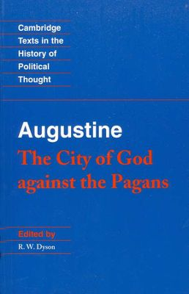
City of God

Augustine of Hippo, The City of God Against the Pagans, trans. R.W. Dyson (Cambridge: Cambridge University Press, 1998)

Summary:

“Most glorious is the City of God,” begins Augustine’s greatest work, The City of God, written from 413-426 AD. A different city, however—Rome—had recently been sacked by the Vandals, and Christianity was blamed. Augustine addresses this charge by juxtaposing two cities. The book has two arguments: first, that Christianity is good for Rome; second, that Christianity is not a false philosophy but that paganism is.

A professor of rhetoric until his conversion, Augustine ultimately became a priest, endured the deaths of his mother and son, and died as bishop of Hippo, in north Africa. His writings act as a bridge between ancient and medieval history.

Themes:

- Suffering. Suffering purifies and purges the righteous; it damns and destroys the wicked.
- Freedom/Free Will. True freedom is the absence of sinful obstructions, freedom from delight in sin, and freedom to delight in God.
- A People. Defined not by language or boundaries, but love. “If we are to discover the character of any people, we have only to examine what it loves.”
- Lust for Mastery. We desire to dominate others. Rather than dominating beasts and nature, we dominate humans. The state is the fullest expression of this.
- Cities. Two loves created two cities: the City of God and the City of Man. The City of God is populated by those predestined by God, his elect, whose self-love is redirected toward God, via grace. The City of Man includes those not chosen by God’s grace.
- Evil. Evil exists because we freely cho(o)se it. As light is a substance and darkness its absence, evil is not a thing but the absence of good.
- Sin. In Eden, humans were able to sin and able not to sin. Presently, we are not able not to sin. In the eschaton, we will not be able to sin.
- Eschaton. The end times are a “seventh day” of history, “whose end will not be an evening.” “God will rest” and give us “rest in Himself.” The eschatological Kingdom of God is not Eden reborn but rather creation renewed, transformed.

Discussion Questions:

- Augustine writes, “[God] is what we ourselves desired to be.” Discuss whether you agree with the following: Every desire you have is based on something God is.
- What are the “marks of glory” Augustine says appear on the resurrection bodies of the saints in heaven?
- Discuss the significance of the book’s full title—The City of God against the Pagans.
- Which word best classifies this book? A work of politics? History? Theology? Apologetics? Philosophy?
- In Bk V.25, Augustine defines a Christian ruler. What are these qualities and their implications?
- Why is it important to note that Augustine holds to a linear view of history?
- What are the differences between the City of God and the institutional/earthly Church?
- Evaluate how Jeremiah 29 says to “seek the welfare of the city” in light of this book.
- Is Augustine an amillenialist?

