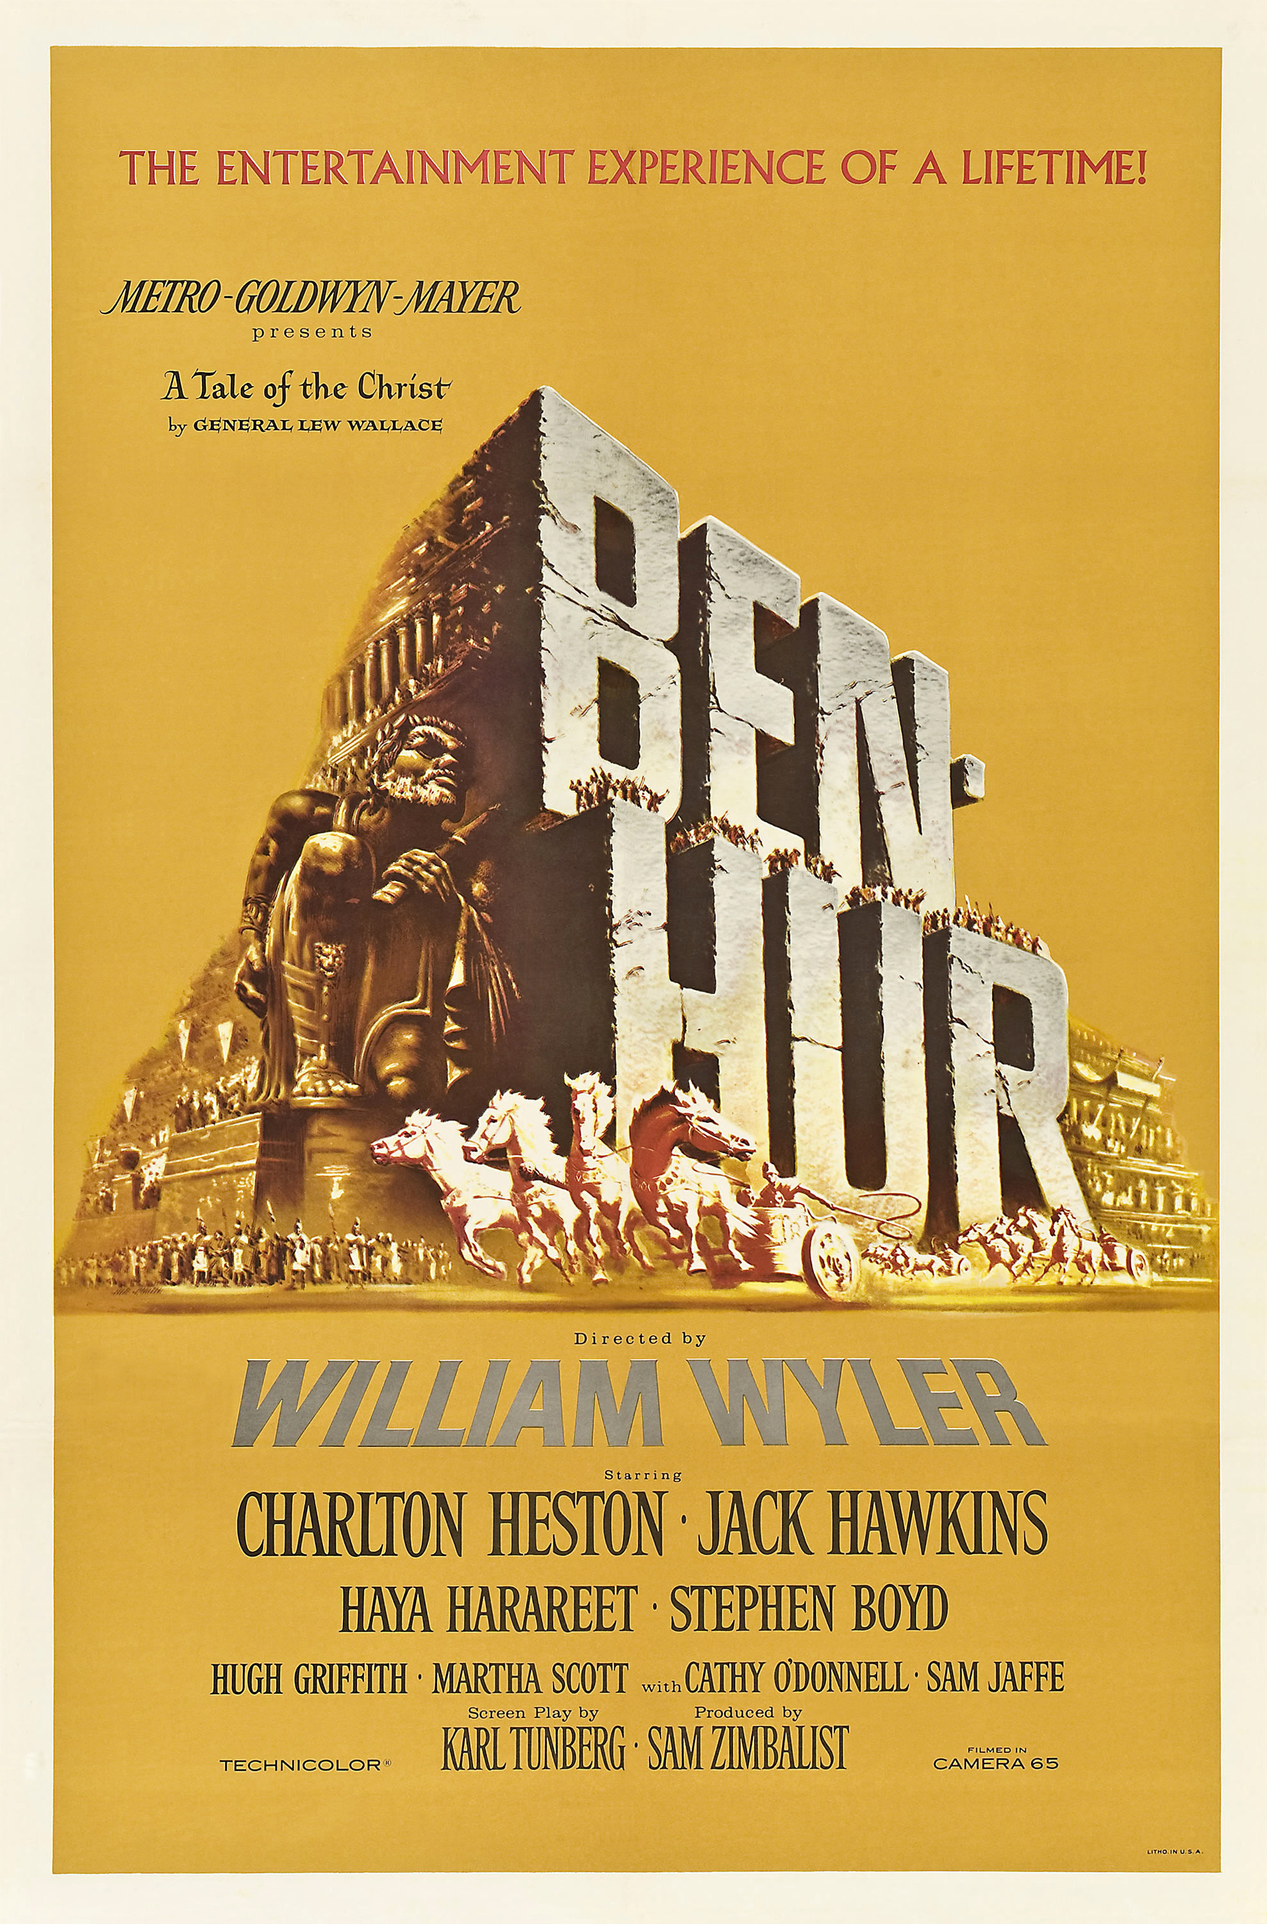
Ben-Hur

Ben-Hur; Metro-Goldwyn-Mayer, 1959; Directed by William Wyler; Starring Charlton Heston, Jack Hawkins, Haya Harareet, Stephen Boyd, & Hugh Griffith; Rated G; Watch the trailer.
Summary:

The production company MGM—think of the roaring lion—was going bankrupt and invested an unprecedented amount of money into a single film in order to save the company. This $15 million gamble had tens of thousands of costumes, the longest score of any film, the longest performance by an actor, the largest set ever built, and 15,000 extras. The chariot scene alone took five weeks to film. The budget was the highest of any movie ever made at the time. The film was so big that it needed an intermission just to process everything, including its running time of 222 minutes. Ben-Hur is based on the 1880 novel Ben-Hur: A Tale of the Christ. The main character is Judah Ben-Hur, a wealthy Jew living in Jerusalem in AD 26. This Jewish prince was childhood friends with a Gentile boy who grows up to be a Roman tribune. Judah is betrayed and becomes first a slave and then a champion charioteer. The epic story is one of romance, revenge, and redemption. Ben-Hur won eleven Oscars—tying Titanic and The Lord of the Rings: The Return of the King for the most wins in history—and enough critical acclaim that the film is still honored and cherished half a century later.

Themes, Symbols, & Motifs:

- Crosses. A cross can be seen over the map at the beginning of the film, at the crossbeams where Judah and Messala throw their spears, at the crucifixion, and in the film’s last frame.
- Revenge & Hate. “Hate keeps a man alive,” Quintus Arrius tells the slaves. Judah for many years is fueled by his desire for revenge, reminiscent of Edmond Dantès.
- Swords. Judah carries and fights with a sword, gifts one to Messala, and says in the film’s last line, “I felt his voice take the sword out of my hand.”
- Water. Water frequently appears, from the shipwreck scene, to Jesus giving Judah a drink, to Judah declaring, “I’m thirsty still,” and most notably in the form of rain during the crucifixion, where it mixes with the blood of Jesus.
- Racing. The metaphor of a race permeates the film: the chariot race, Messala’s dying words—“It goes on, Judah. The race…is not over!”—as well as an overall echo of Paul’s “I have finished the race” from 2 Timothy.

Discussion Questions:

- Why do the credits appear against Michelangelo’s Sistine Chapel fresco “The Creation of Adam”?
- The director chose not to show Jesus’s face or have him speak. What effect does this have?
- Why is the novel version of the story subtitled A Tale of the Christ?
- What does Esther mean when she says to Miriam, “The world is more than we know”?
- What is the significance of the last image of the film with the empty crosses, flock, and shepherd?

