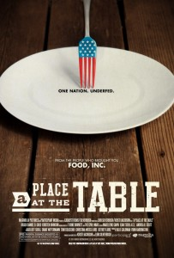
A Place at the Table

A Place at the Table; Magnolia Pictures, 2012; Directed by Kristi Jacobson & Lori Silverbush; Music by The Civil Wars & T Bone Burnett; PG. Watch the trailer.

Summary:

Jeff Bridges, actor and co-founder of the End Hunger Network, says in reference to problem of hunger in America, “If another country was doing this to our kids, we would be at war.” 50 million Americans (and 1 in 4 children) fall into the category “food insecure.” One out of every two kids in the United States will be on federal food assistance at some point in his or her life. A Place at the Table is a documentary from the creators of Food, Inc. that proposes that people go hungry not because of a food shortage, but because of poverty.

Themes:

- Processed food. Most often, the cheapest food is processed food such as soda, chips, cookies, and cereal.
- Poverty/Hunger. The film ties these concepts together, stating that the former perpetuates the latter.
- Food insecurity. Food security relates to a lack of access to the certain quantity and quality of food.
- Diet-related diseases. Americans, especially children, are experiencing a rise in diet-related diseases such as type 2 diabetes.
- Affordability and availability. The film purports that charities and churches are an insufficient solution and that the government must intervene to increase the affordability and availability of healthy food.

Discussion Questions:

- Compare and contrast the factors leading to hunger with Barbie, Rosie, Tremonica.
- Whose story most affected you and why?
- What is a food desert?
- What is the relationship between poverty and obesity?
- How does the film tie together food insecurity and cyclical poverty?
- What comes to mind when you hear the words “food stamps”? Compare your thoughts to the current food stamp program SNAP (Supplemental Nutritional Assistance Program), as explained in this video.
- What role do agricultural subsidies play in all this?

