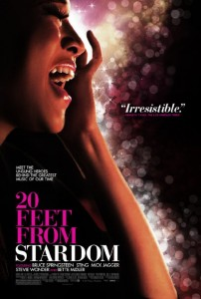
20 Feet from Stardom

20 Feet from Stardom, Tremolo Productions, 2013; Directed by Morgan Neville; PG-13. Watch the trailer.

Summary:

Many of our favorite songs feature backup singers who often get overshadowed by the lead singer. Think of “Gimme Shelter” by the Rolling Stones or “Hit the Road Jack” with Ray Charles. Often the backup singers are the ones who make the song work and make it memorable. Countless artists have used backup singers, from Stevie Wonder, Mick Jagger, Diana Ross, Elton John, Bruce Springsteen, to Sting. This documentary chronicles the journey of a handful of female backup singers as they perform near, but often not in, the spotlight. Some attempt solo careers, with varying degrees of success. Directed by Morgan Neville, who has done many documentaries on musicians, 20 Feet from Stardom went on to win the 2014 Academy Award for Best Documentary Feature.

Themes/Subjects:

- “Making it.” Defining this is difficult—money? recognition? albums?—but all the singers in the film seem to know it when they see it.
- Work ethic/talent/passion. Nearly every singer in the film has these qualities but (curiously) some are far more successful than others.
- Limits. The film explores at what point a singer should question whether he or she should consider a career change or persist with the dream.

Discussion Questions:

- What do you make of the concept of “making it” it in the celebrity business?
- So many of the backup singers began their singing while growing up in church. Why is that?
- How have shows like The Voice and American Idol affected our conceptions of singing and singers?
- How do you tell the difference between a healthy dream and a destructive obsession?

