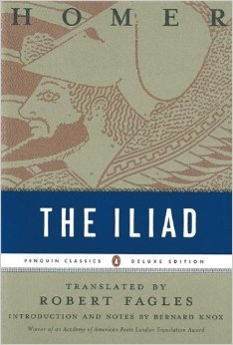
Homer, The Iliad, trans. Robert Fagles (London: Penguin Classics, 1998)

Summary:

Homer, the ancient blind bard, is credited as the author of the 8th century BC epic poem The Iliad, a story of the ten-year Trojan War. The actual poem, however, focuses only on events in the final few weeks of the war, events beginning with an argument between the Achaean (Greek) king Agamemnon and the greatest Achaean warrior—Achilles. Likely the most famous fictional story in Western literature, The Iliad and events surrounding the Trojan War are responsible for much of our exposure to Greek gods, war stories, and the concepts of a Trojan horse and an Achilles’ heel. This translation by Robert Fagles is fast-paced and accessible, balancing between neither being too literal nor literary.

Themes, Symbols, & Motifs:

- Shield. Achilles’ shield depicts instances of everyday life. It is holistic, even a rebuke of Achilles’ bloodlust. One way to read the shield is that each scene has also depicted its opposite.
- Love & Hate. These two themes equally motivate multiple characters. At times, their distinction is even blurred.
- Rage. This is a story of rage—its genesis, climax, and end. From the tale’s first word to a cooling of rage at the end that might even be an instance of compassion, most of the story’s action can be traced by following the presence and level of rage.
- Fate. Its origin is unknown—even the gods cannot control it—yet Zeus or the Fates reveal fate. All are bound to its will.
- Honor. Closely related to pride, honor, particularly in battle, takes precedence time and again over one’s family or personal safety.

Discussion Questions:

- Choose a passage and compare the Fagles translation to those by Robert Fitzgerald and Richmond Lattimore.
- Would you agree with others who have said this is the bloodiest or most violent and graphic story ever told?
- If Achilles has two fates—two he is able to choose—is this truly fate? Is this free will?
- Achilles is given the choice between kleos (glory) or nostos (home). Does he make the right decision?
- How are women treated or portrayed? Consider Hera, Athena, Aphrodite, Briseis, and Andromache.
- What is the difference between fate, destiny, and providence? Relate these to the poem.
- Where in the story are occasions of love? What kind of love?
- What is the role of the gods? Are they helpful? Moral?
- At any point in the poem, should Hector have acted differently? Does he remain noble? Does Achilles? Agamemnon?
- Bernard Knox says in the introduction, “War has its deadly fascination for those who have grown up in its service.” Do you agree?
- In Book 6 Diomedes and Glaucus agree not to fight each other because of an oath made by their grandfathers. Is this friendship? A covenant? Would this happen in the present day?

