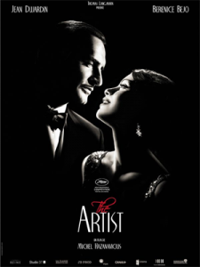
The Artist

The Artist; Warner Bros., 2011; Directed by Michel Hazanavicius; Starring: Jean Dujardin, Bérénice Bejo, John Goodman, and James Cromwell; PG-13. Watch the trailer.

Summary:

The Artist is a black and white silent film about black and white silent films. It is a love story between two people but also a love story of motion pictures. Set between 1927-1931, the film follows George Valentin, a gregarious and famous silent film actor who refuses to make films with sound once “talkies” enter the cinema scene. He meets a young woman named Peppy Miller, who works her way up from an extra on the set to being an international star. George loses his wife, home, chauffer, career—everything but his dog, and his friendship with Peppy. The Artist was shot in Los Angeles in only 35 days. The actors who play George and Peppy are not trained dancers and spent five month in dance and tap lessons for a two-minute dance routine at the film’s conclusion. The film won five Academy Awards, including Best Picture, Best Director, and Best Actor and regularly concluded with audiences applauding.

Themes, Symbols, & Motifs:

- Image. Silent films are all about the image, that which is within the frame. The narrative must be told solely within the frame.
- Talking. George refuses to “talk” in his films; he even has a dream where he literally cannot speak.
- Relationships. Each relationship in the film is charged and layered: George with his wife, George with Peppy, George with Clifton, and George with his dog Uggie.
- Transition. From George and Peppy’s lives to the introduction of talkies to the start of the Great Depression, the film engages with many periods and instances of change.
- Language. Nearly everyone in the story alternately fails and succeeds to communicate. Music is another language in the film. Also, the main actors and director are all from France.

Discussion Questions:

- Why do you think the title of the film is The Artist and not The Actor or The Star?
- How does music function differently in this film than others?
- Trace the creation, fall, and redemption of George.
- Film critic A.O. Scott said in the New York Times, “[This] film is less a faithful reproduction than a tasteful updating” of black and white silent films. Do you agree?
- George Valentin and Peppy Miller are main characters, but how could Hollywood be considered another character?

